Born to be Wild
Steppenwolf
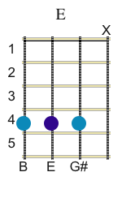
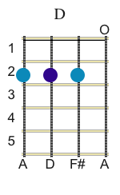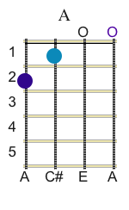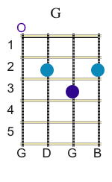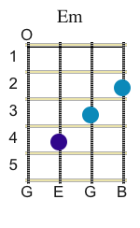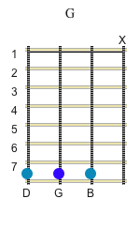
INTRO:
E E E E D A

E E E E D A

E E E E E

E D A
Get your motor runnin'
E D A
Head out on the highway
E D A
Lookin' for adventure
E D A
In whatever comes our way

G A E
Yeah, darlin' gonna make it happen
G A E
Take the world in a love embrace
G A E G A E(Em) 1st time)
Fire all of the guns at once and explode into space

E D A
I like smoke and lightnin'
E D A
Heavy metal thunder
E D A
Wrestlin' with the wind
E D A
And the feelin' that I'm under

Chorus
E
Like a true nature's child
G
We were born, born to be wild
A G Em
We could climb so high, I never wanna die

E D A D
Born to be wild,
E D A D
Born to be wild,

Ad lib chord solo

E E E MUTE E E E MUTE G G G MUTE G G G MUTE

E E E D A D E E E D A D E E E E End 2nd time

Repeat first verse

