Joy To The World
Three Dog Night
Chords
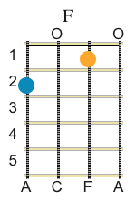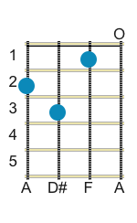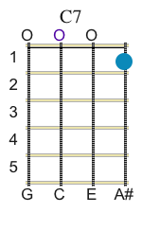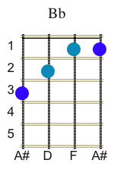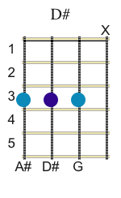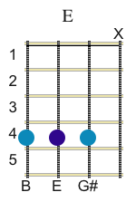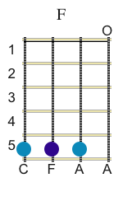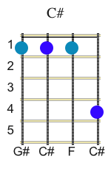

Key: F
INTRO
2 2 4 2 2 4
Eb E F Eb E F
Jeremiah was a bullfrog was a good friend of mine
F F7 Bb F C 7 F
I never understood a single word he said but we always had a good time
F C 7 F
Yeah we always had a mighty fine time singin`

CHORUS
F C7 F
Joy to the world. All the boys and girls now.
F F7 Bb F C7 F
Joy to the fishes in the deep blue sea joy to you and me.

Instrumental break
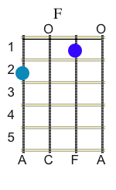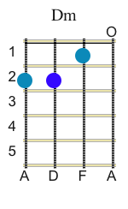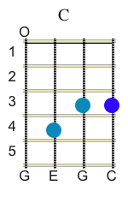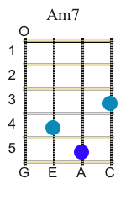
1 1 1 1 1 1 1 1 1 1 1

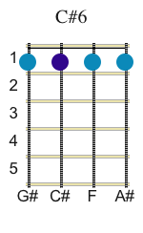
1 1 1 1 2 2 2 2 2 2 2

Eb E F Eb E F Eb E F
If I were the king of the world I tell you what I`d do
F F7 Bb
I`d throw away the cars and the bars in the world
F C7 F
and spend my time with you singin` now

CHORUS
F C7 F
Joy to the world. All the boys and girls now.

F F7 Bb C# F C7 F
Joy to the fishes in the deep blue sea joy to you and me.

F F7 Bb C# F C7 F
Joy to the fishes in the deep blue sea joy to you and me.

Instrumental break
1 1 1 1 1 1 1 1 1 1 1

1 1 1 1 2 2 2 2 2 2 2

Additional Lyrics

Eb E F Eb E F Eb E F
You know I love the ladies love to have my fun
F F7 Bb
I`m a highlight flyer and a rainbow rider
F C F
a straight shootin` son of a gun alright!
F C F
I said a straight shootin` son of a gun.

Refrain.

F C F
Joy to the world. All the boys and girls now.
F F7 Bb F C F
Joy to the fishes in the deep blue sea joy to you and me.

F C F
Joy to the world. All the boys and girls
F F7 Bb F C F Eb E
Joy to the fishes in the deep blue sea joy to you and me.

G C G
Joy to the world. All the boys and girls.
G C G
Joy to the world. Joy to you and me.

F C F
Joy to the world. All the boys and girls.
F F7 Bb F C F
Joy to the fishes in the deep blue sea joy to you and me.

Repeat and fade.

