SMOKE ON THE WATER
Deep Purple
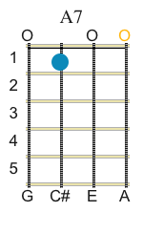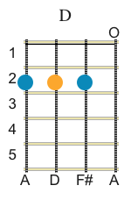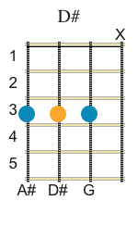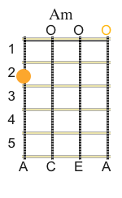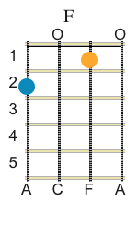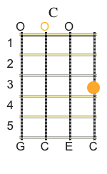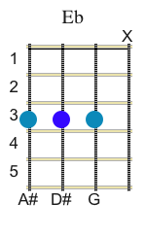
INTRO

A7 C D A7 C Eb D A7 C D C

A7 C C A7 C A7 C C

A7 C C A7 C

A7 C D A7 C Eb D A7 C D C

A7 C D A7 C Eb D A7 C D C

A7 C D A7 C Eb D A7 C D C

Verso 1:
A
We all came out to Montreux
C D Am
on the lake Geneva shoreline

To make records with a mobile -
C D Am
we didn't have much time

Frank Zappa & the Mothers
C D Am
were at the best place around

But some stupid with a flare gun
C D Am
burned the place to the ground.

D F
Smoke on the Water
C6
Fire in the sky

D F
Smoke on the Water

A7 C D A7 C Eb D A7 C D C

A7 C D A7 C Eb D A7 C D C

--0-3-3-0-3-0-3-0-3-0-3-5-6-5-3-0-3-0-3-5-6-5-3-0-3
---------------------------------------------------
---------------------------------------------------
---------------------------------------------------

-5-6-7-6-7-6-7-10-11-12 C A END
-----------------------
-----------------------

Additional lyrics

Verse 2:
Am
They burned down the gambling house -
C D Am
it died with an awful sound

Funky & Claude was running in and out,
C D Am
pulling kids out of the ground

When it all was over,
C D Am
we had to find another place

Swiss time was running out -
C D Am
it seemed that we would lose the race.

Refrain:

Riff principal=2x

Solo

Riff principal=2x

Verso 3:

Am
We ended up at the Grand Hotel -
C D Am
it was empty, cold and bare

But with the Rolling Trucks Stones thing just
C D Am
outside, we made our music there

With a few red lights an' a few old beds,
C D Am
we made a place to sweat

No matter what we get out of this,
C D Am
I know, I know we'll never forget.

